DATA UNLOADING IN SNOWFLAKE
We will go through data unloading, which is exactly the reverse of data loading.
What we do is we get the data from snowflake and copying it back to file
Steps to unload:
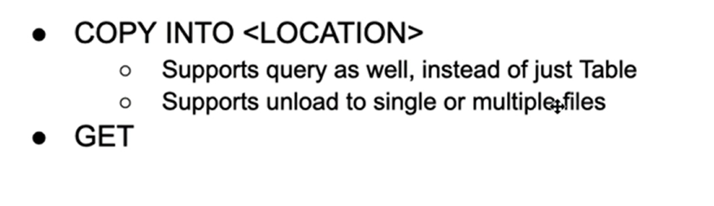
A diagram from snowflake documentation on data unloading:
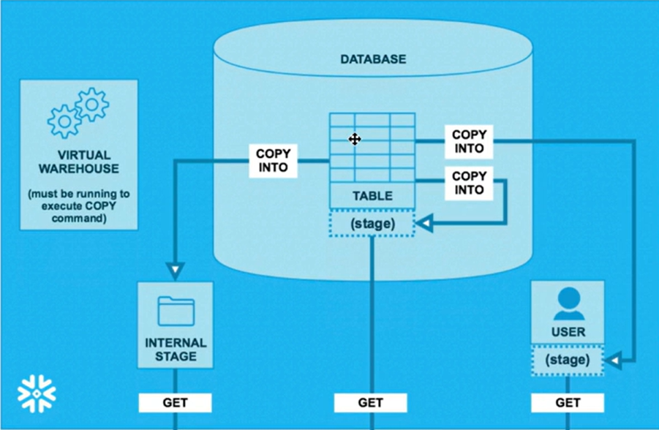
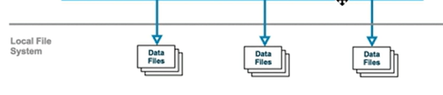
Case1:
Let’s do hands on data unloading using user stage
Create the table for user stage data
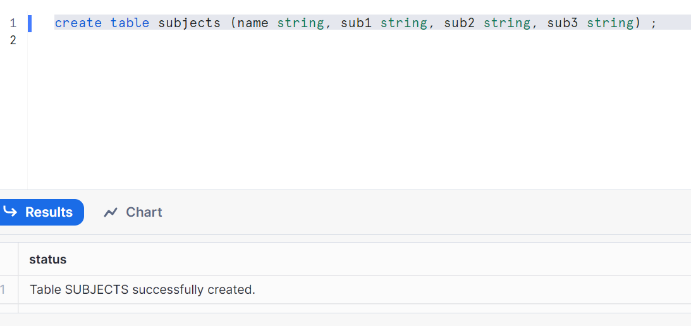
Inserting the data
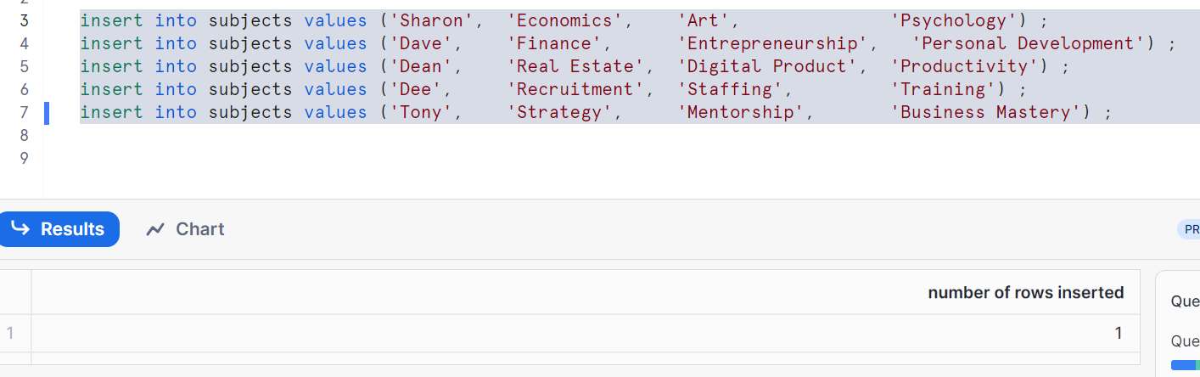
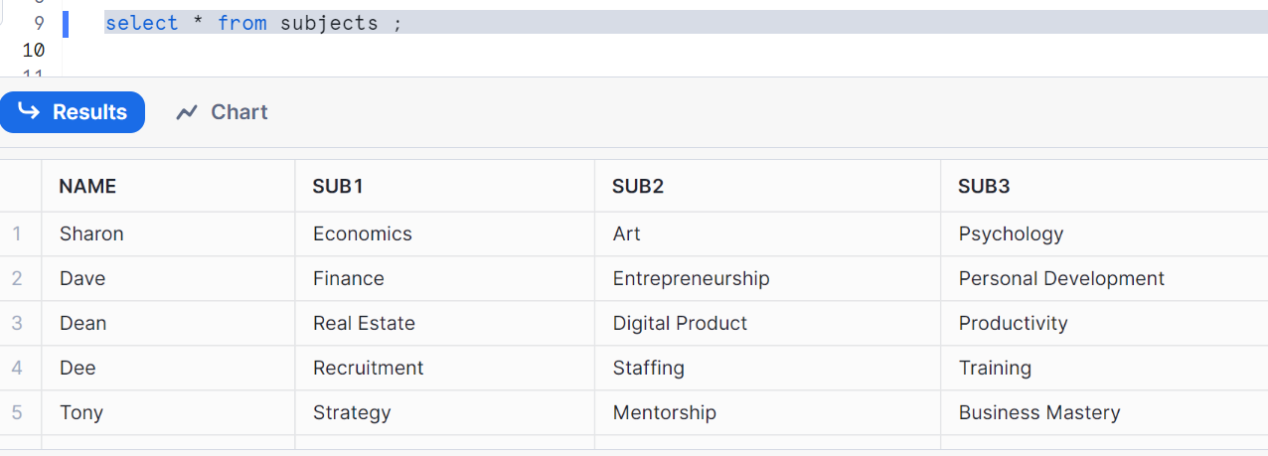

Copy table into user stage
Note: since snowflake automatically compresses file into zip, I don’t want compression. Hence compression= none so that I get my file in the format type csv.
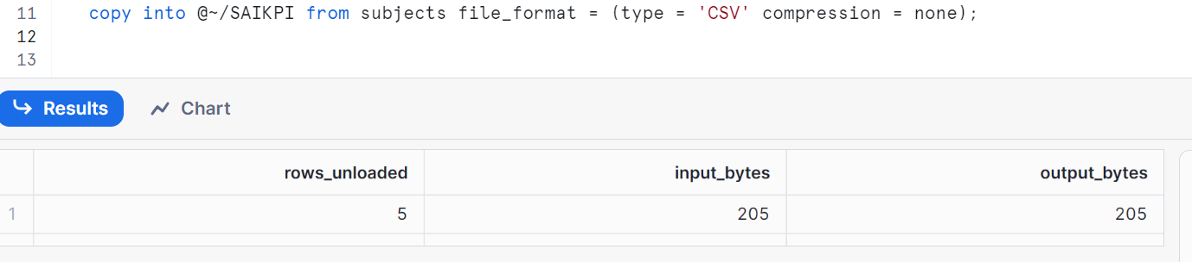
Check user stage
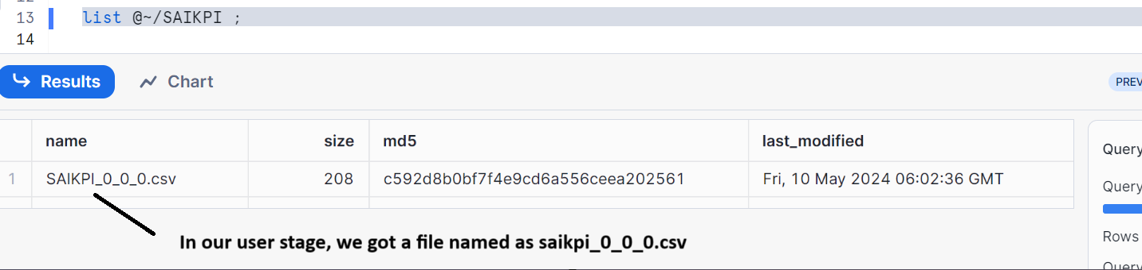
Let’s see the data in stage
Note: [select * from @~/SAIKPI t;] doesn’t work in user stage. It only works in table stage
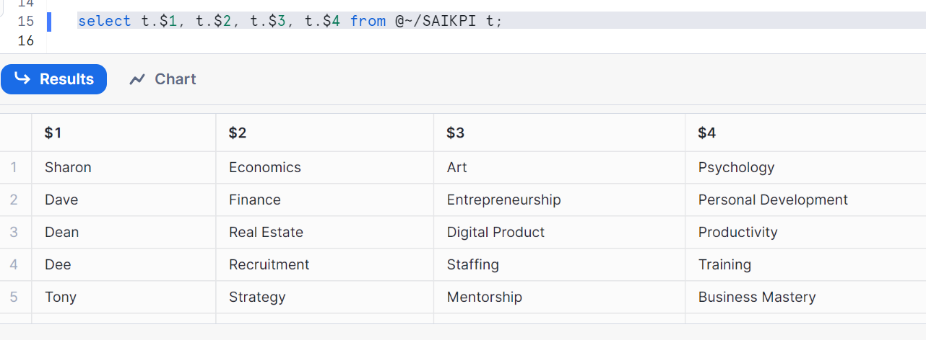
Pushing the data from stage to local
If u run the below in snowsql to get data into your local folder from stage,
In order to prevent, remove the stage name and run
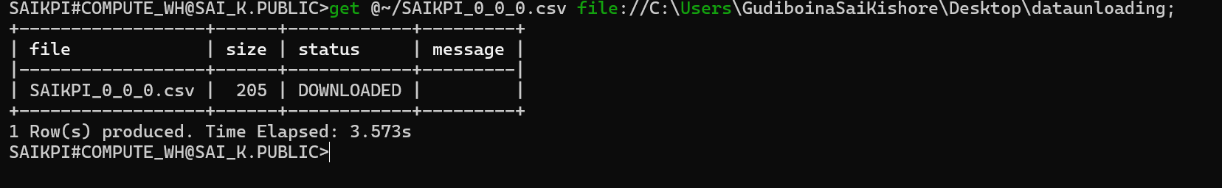
Let’s check the file in my local
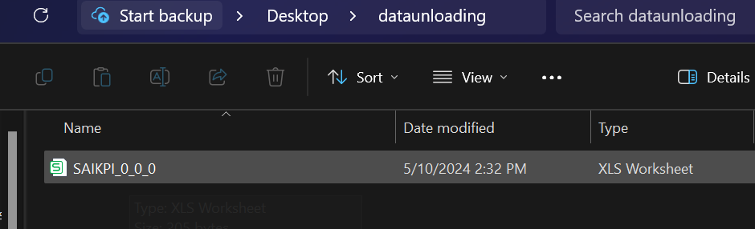
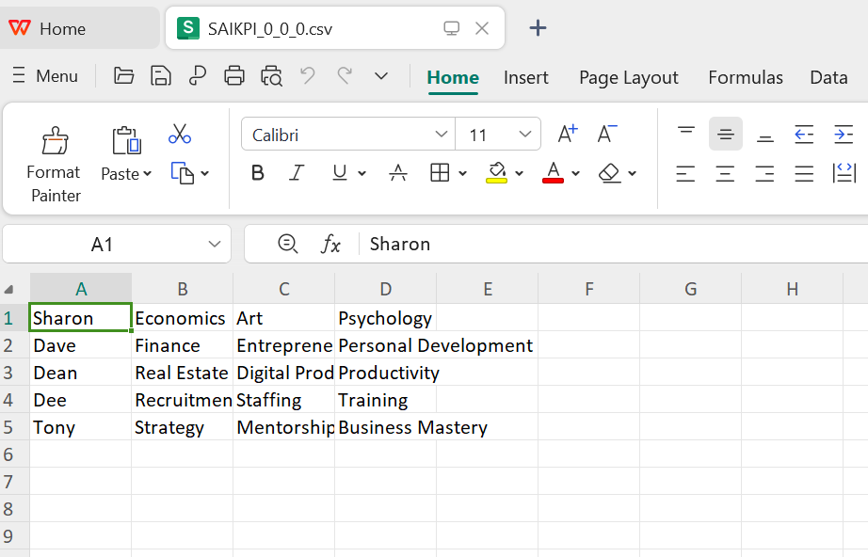
Let’s clean up
Drop table subjects;
Remove @~/SAIKPI pattern='.*.csv’;

Case2: data unloading using table stage
Create Table
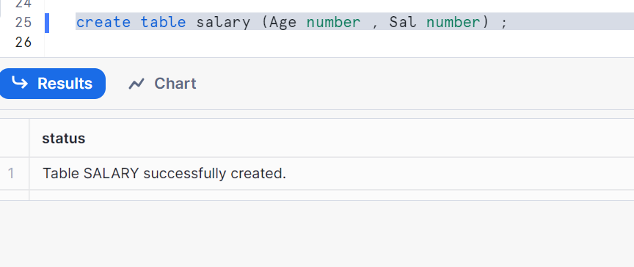
Insert data
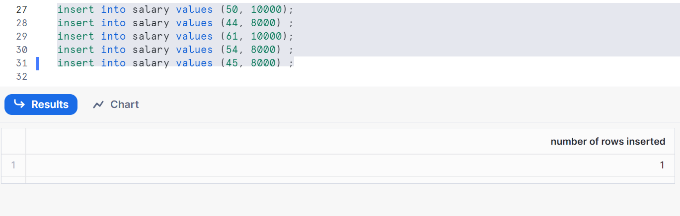
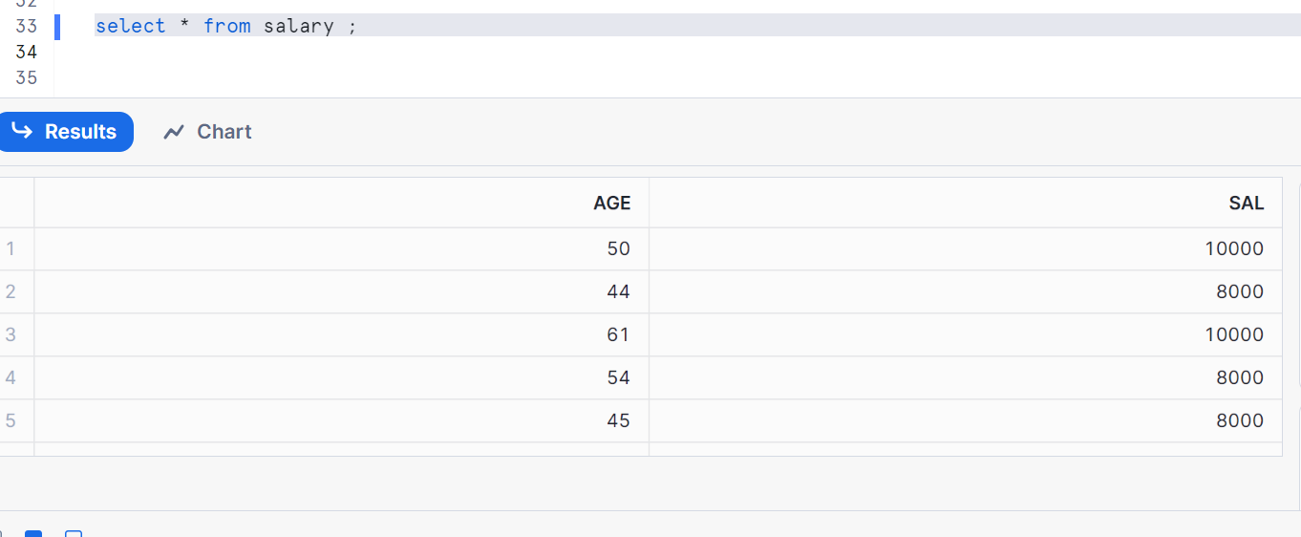

Copy table into user stage
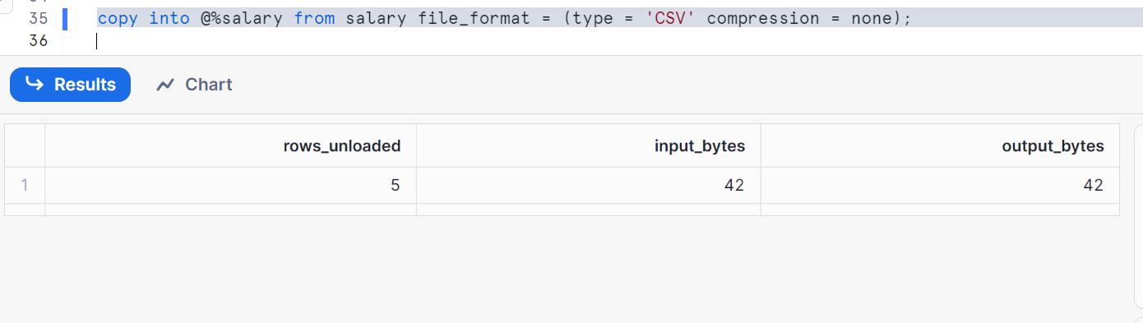
Check table stage
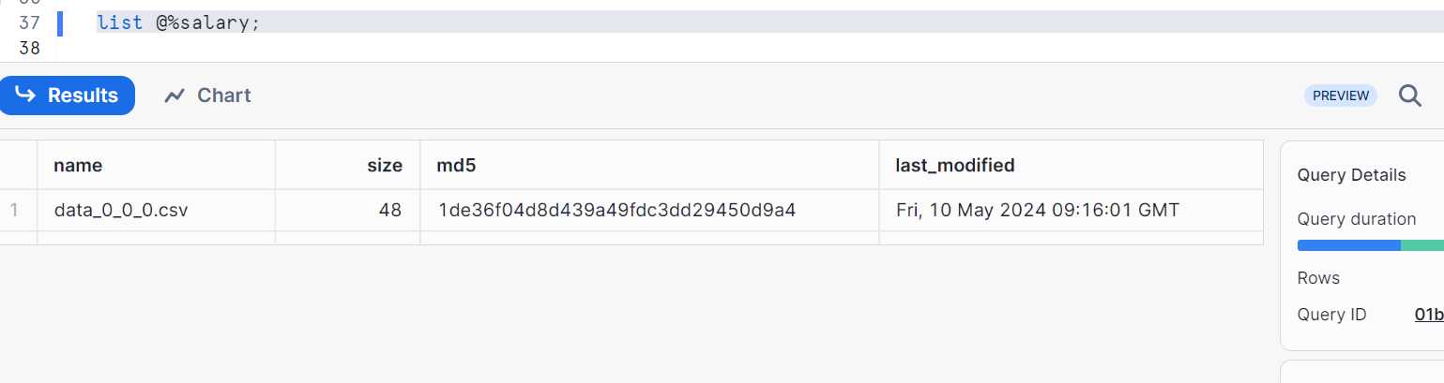
Select * works here
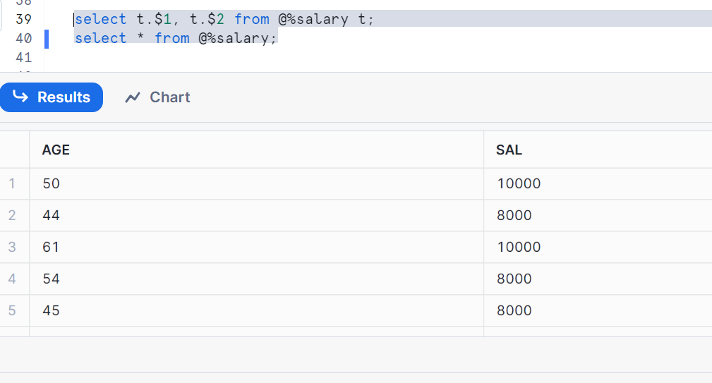

Pushing data from stage to local folder
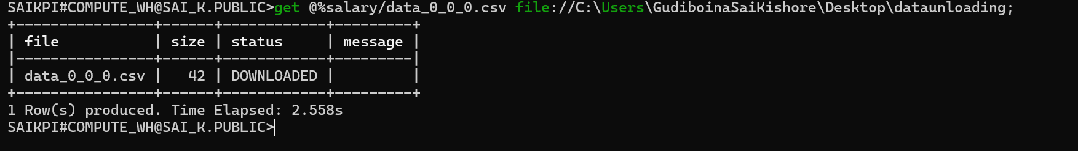
Let’s check the file in my local
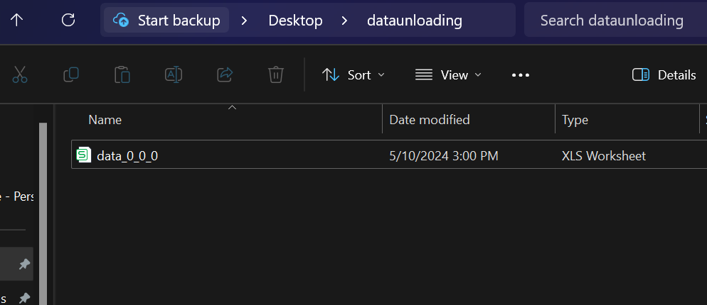
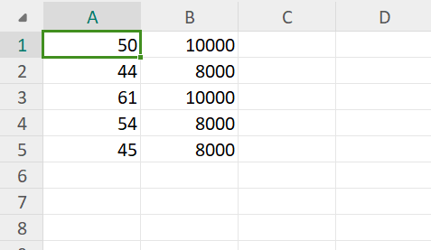
Clean up:
Drop table salary; -- dropping table will remove the data from stage table_stage
OR
Remove @%salary pattern='.*.csv’; -- to reload, we can remove the files.

Case 3: data unloading using internal named stage
Create a table and insert values
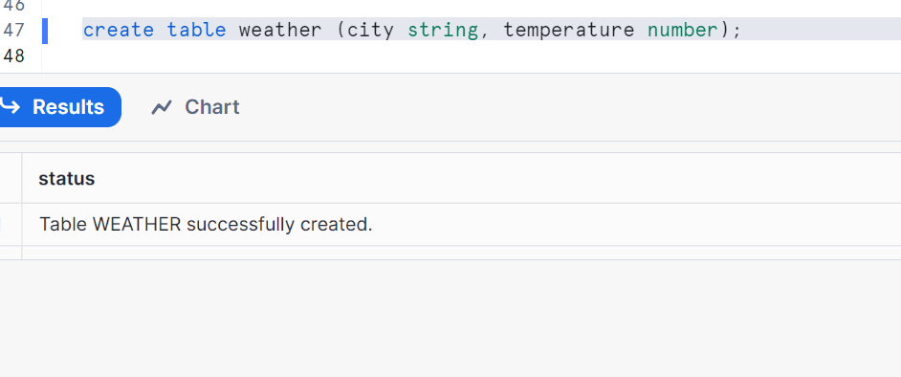
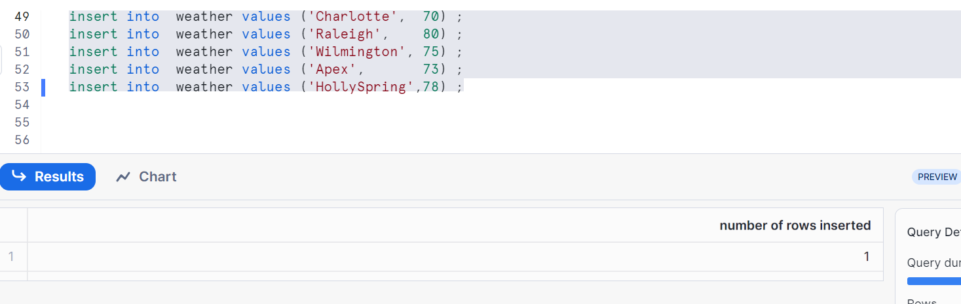
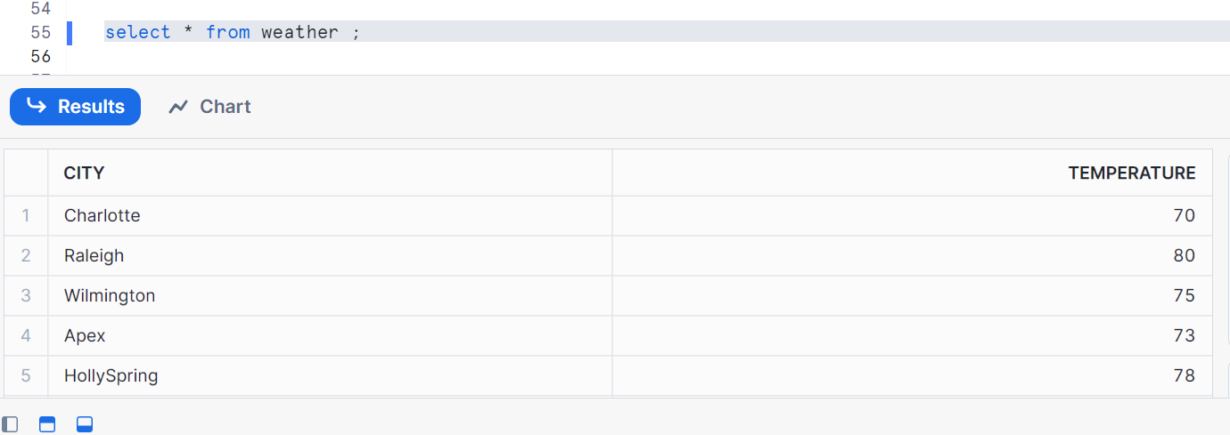

Create internal stage with the name as ‘shared_stage’’ (note: if you give a URL to it that becomes an external stage)
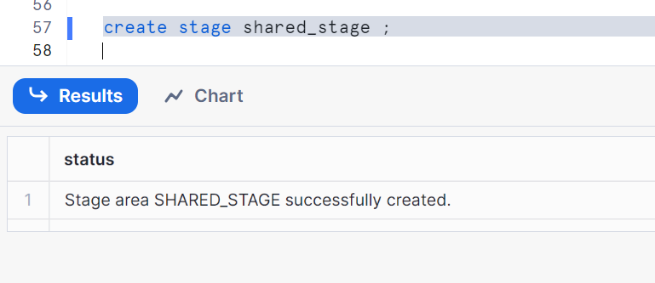
Show all stages
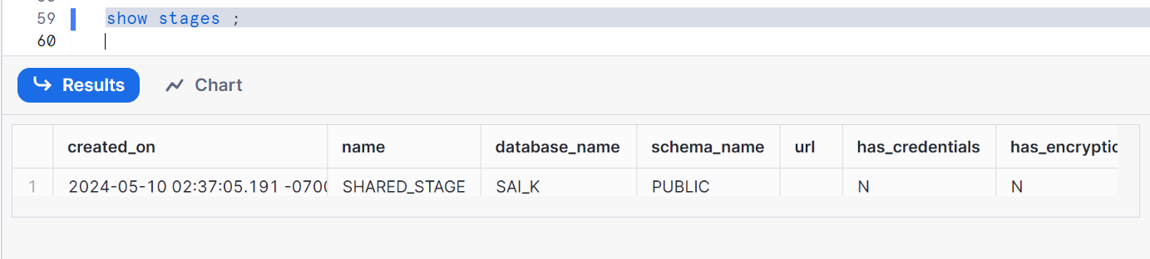
Copy table to named stage
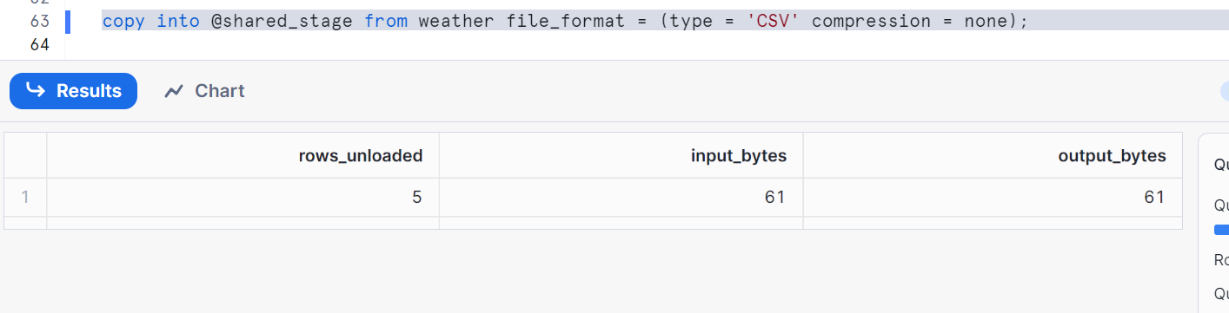
Check table stage now where we got our file in it
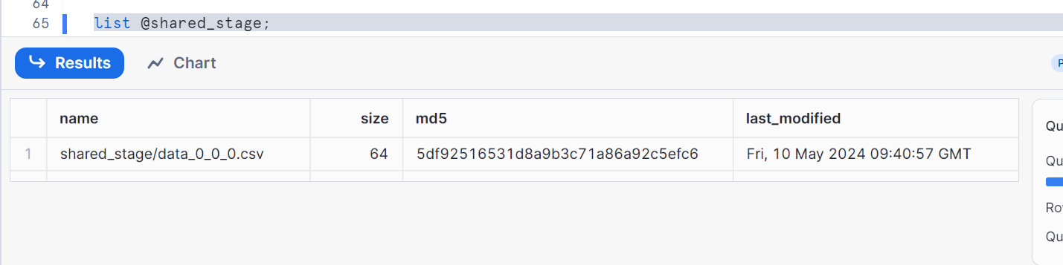

Pushing data from stage to your local (note: delete the files if any having with same name if exists in your local folder)
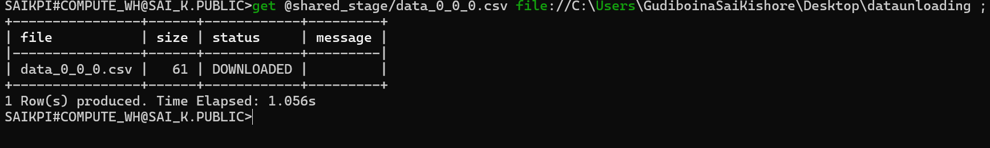
Let’s check the file in my local
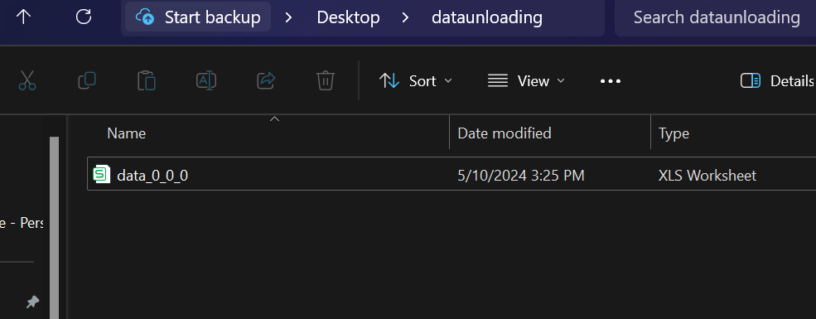
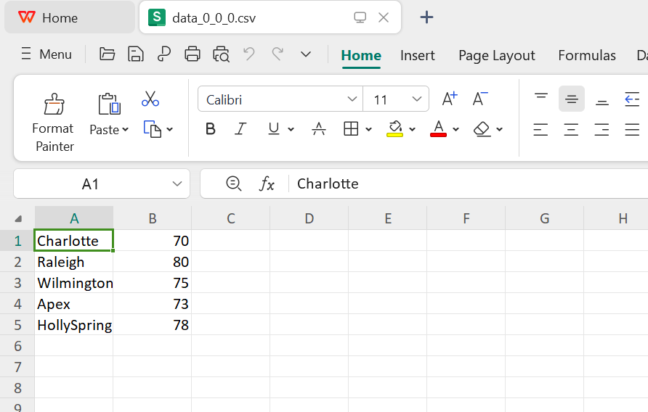

Clean up:
Drop stage shared_stage;
Drop table weather;

UNLOADING USING QUERY
Create a table to load internal named stage data
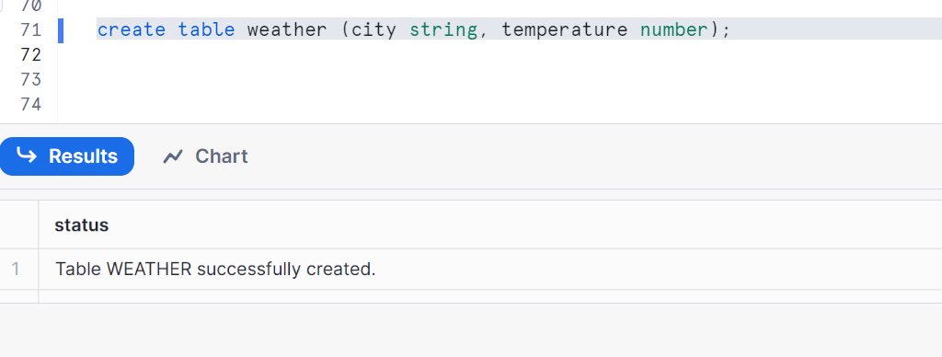
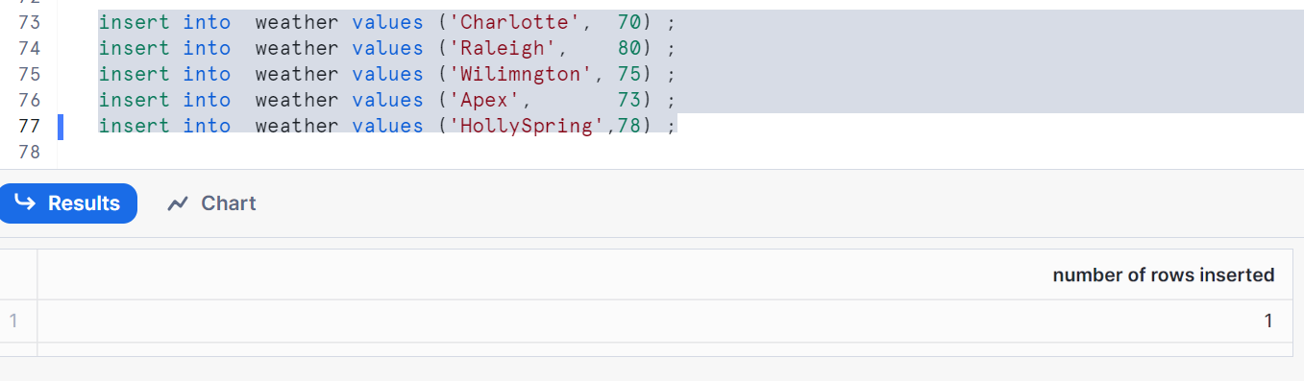
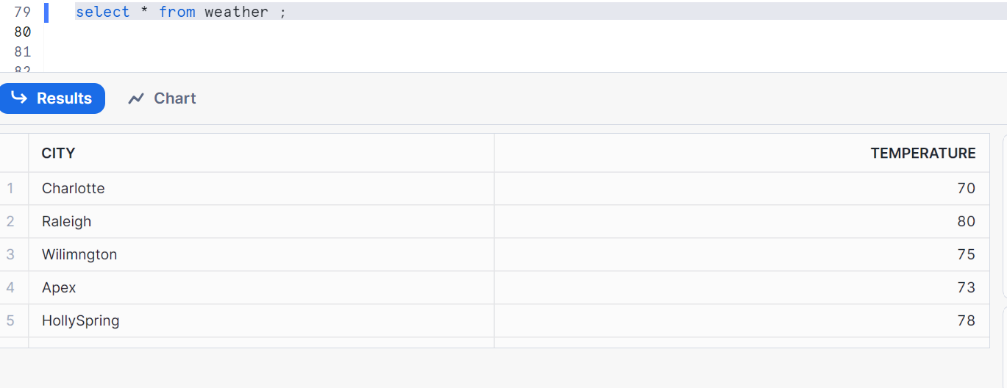
Create internal stage with the name as ‘shared_stage’’
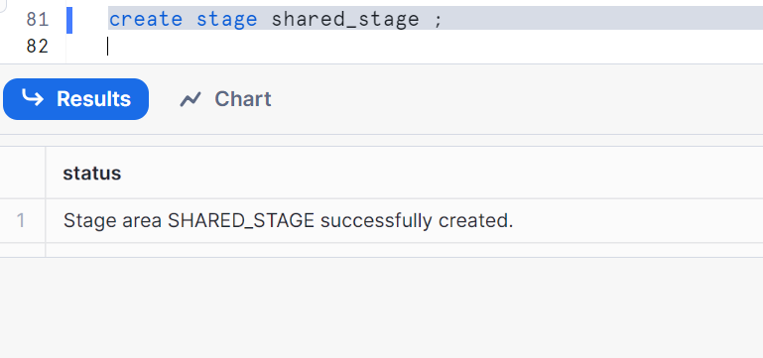
Show stages
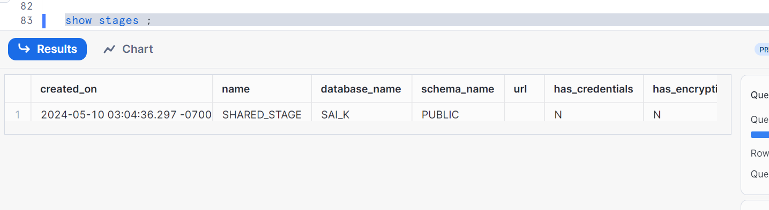
Copy table containing only column ‘city’ from table by query to stage as shown
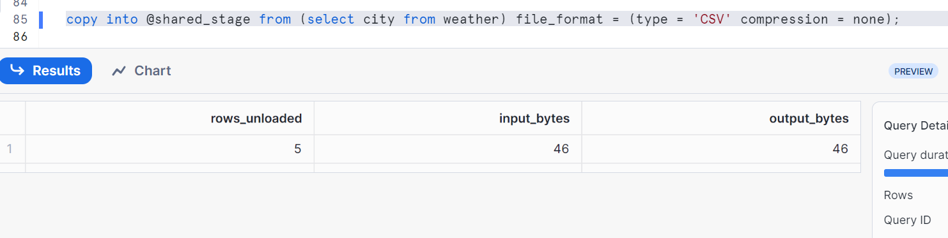
Check stage containing files
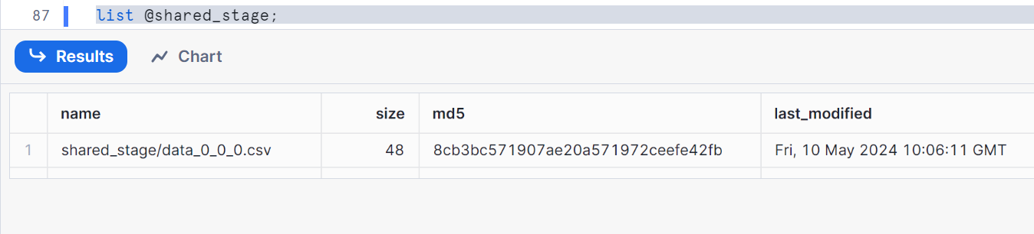
Now, let’s push from stage to local
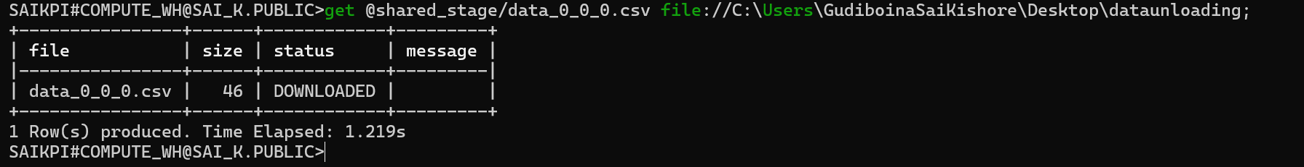
Let’s check the file and data
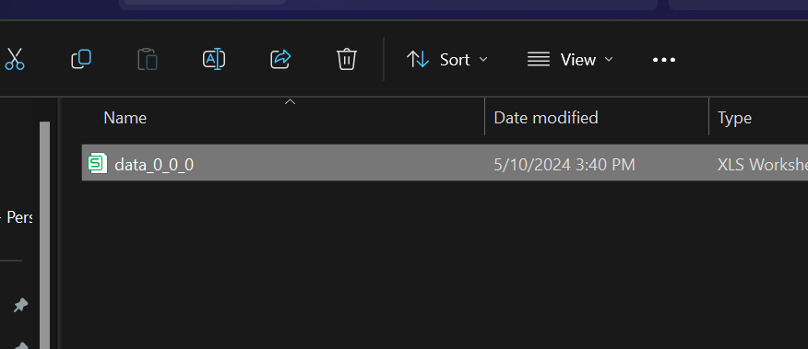
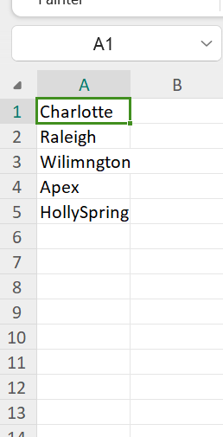

UNLOADING MULTIPLE FILES
Let’s do hands on
Create a table to load internal named stage data (let’s take some huge file)
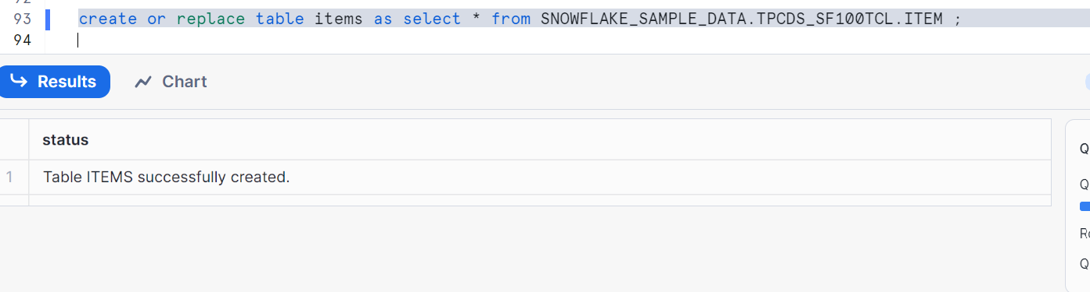
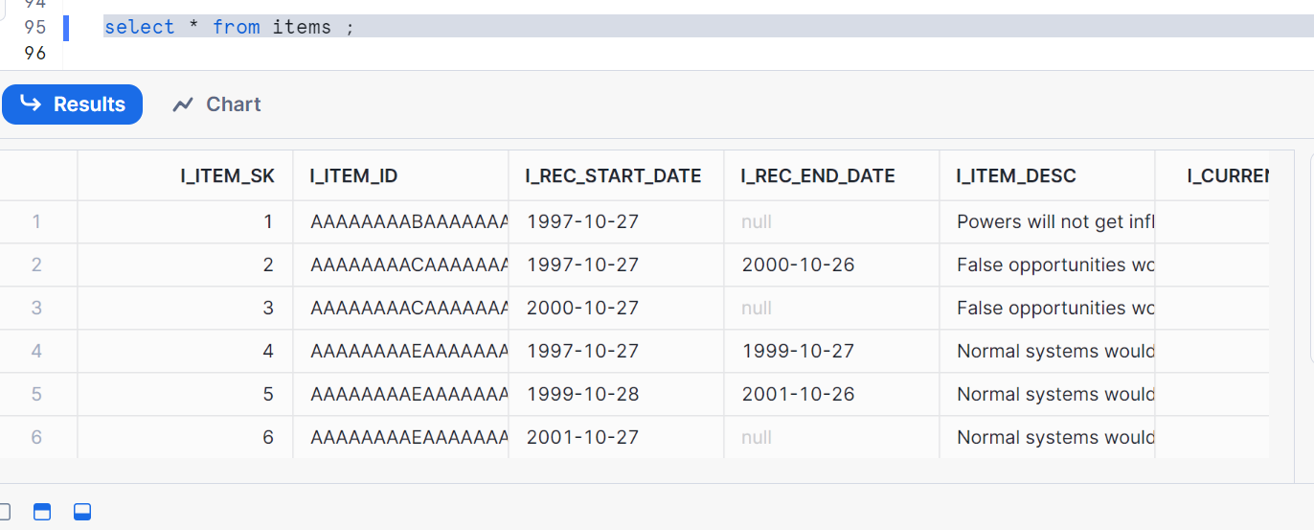
Create internal stage with the name as ‘shared_stage’
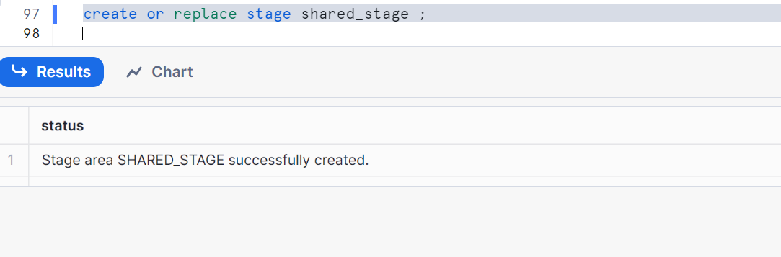
Show all stages
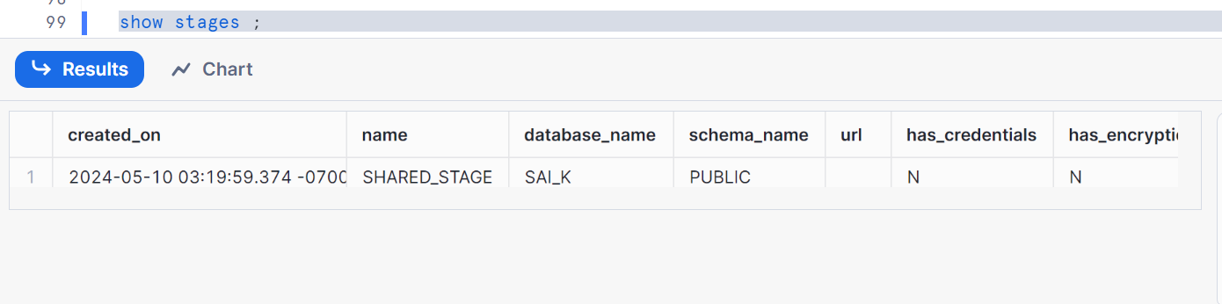
Copy table into stage
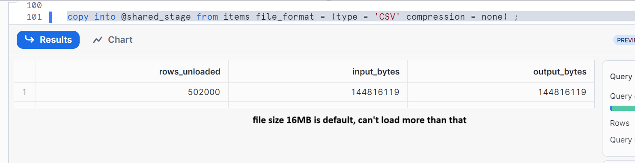

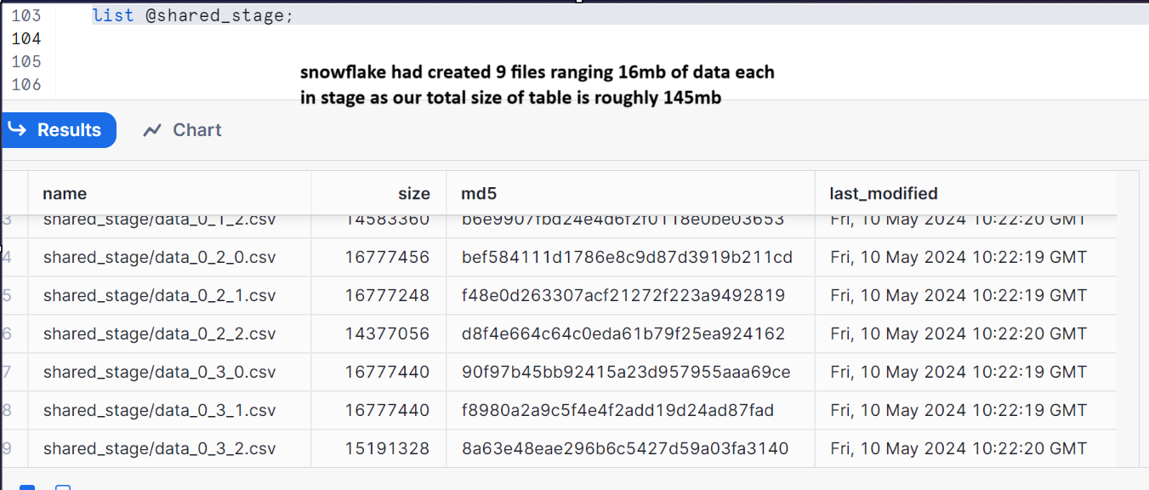

I want all the data from the table items into just one file
Remove all the files in shared_stage
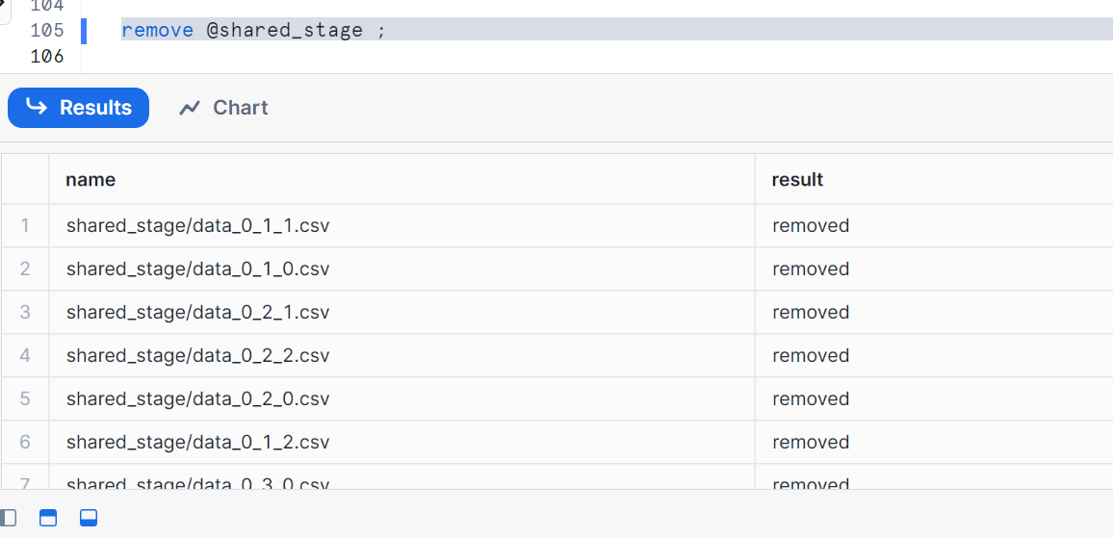
Now, let’s give single= true and max_file_size=15mb approx.
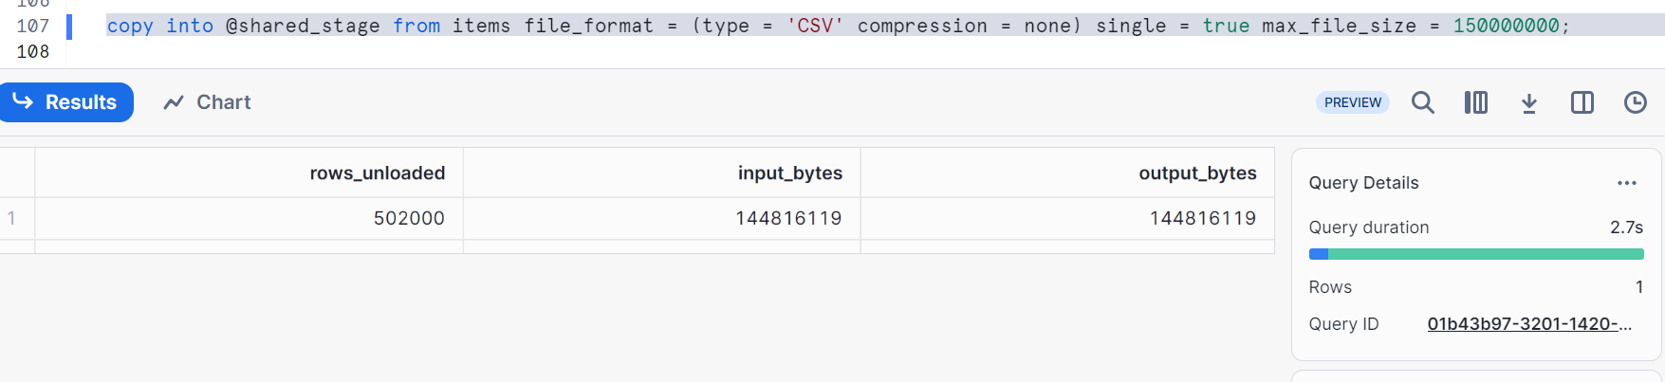
Let’s check now
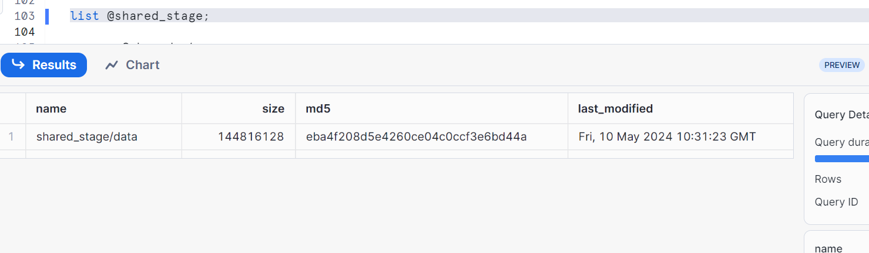
Let’s try different sizes now
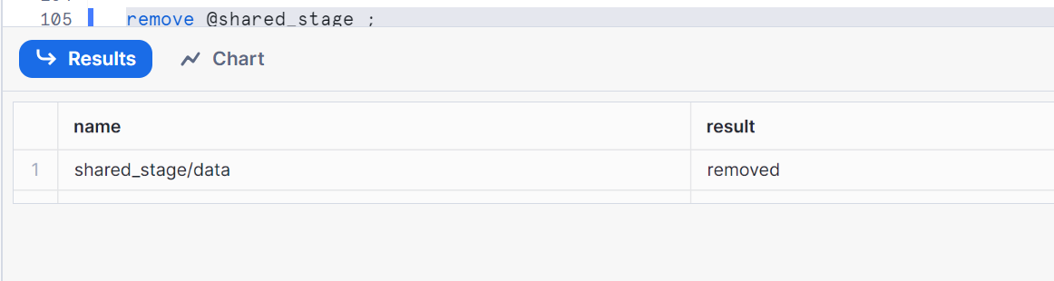
Removed single=true and max_file_size=10mb
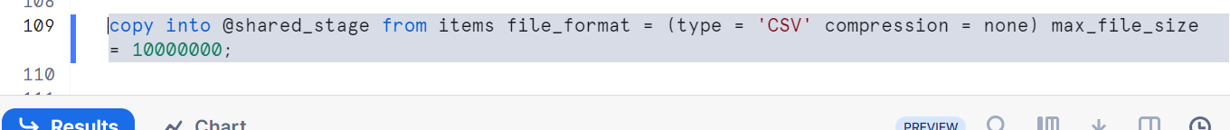
It created 15 files each ranging 10 mb
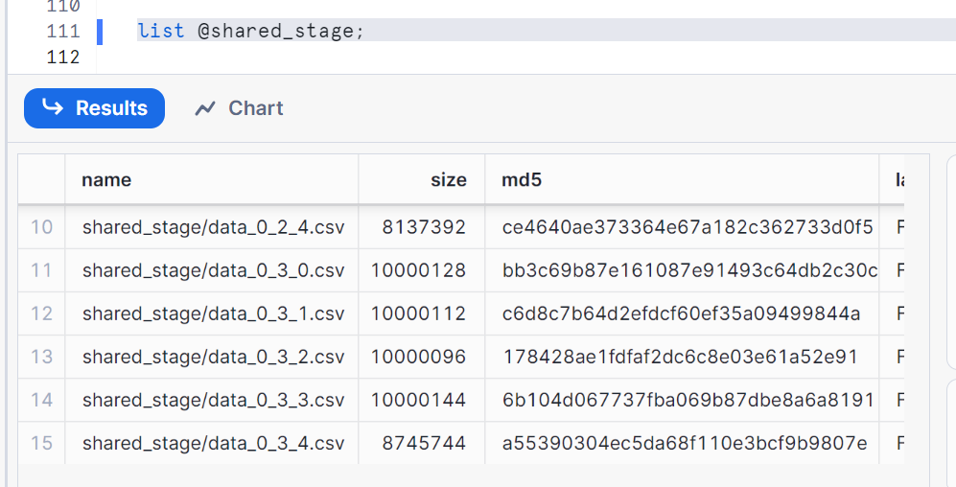
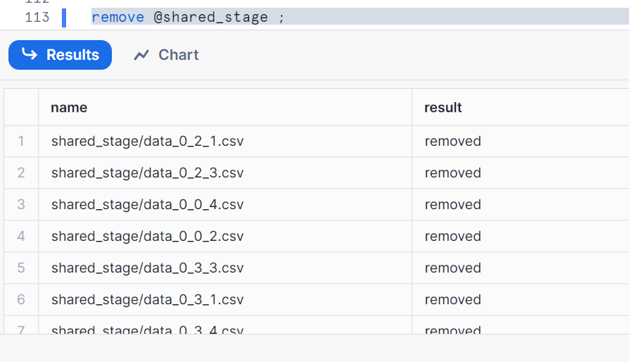
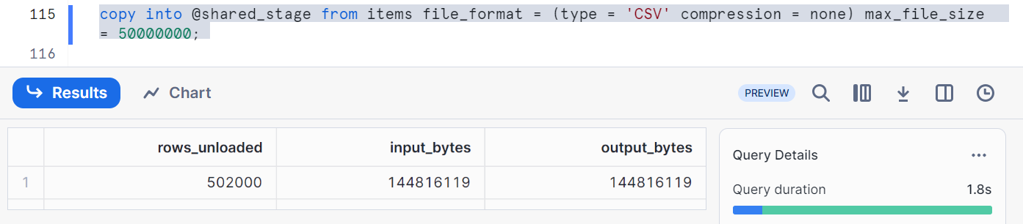
It created 3 files ranging 50mb as our main table is of approx 145-150mb
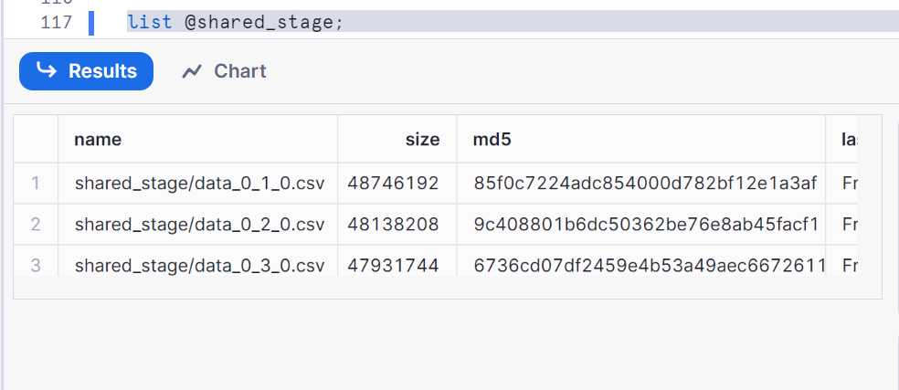

Now let’s push these files into our local
Let’s check in our local
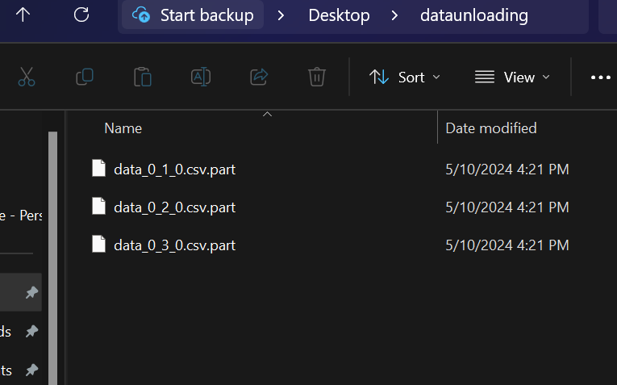
All 3 files are into our local

Thanks

